**Nama : Andrian Kaspari**

**Nim : 09011182126004**

**Dig :**

Google.com

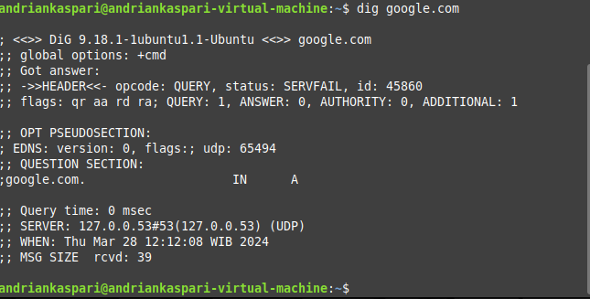

Instagram.com

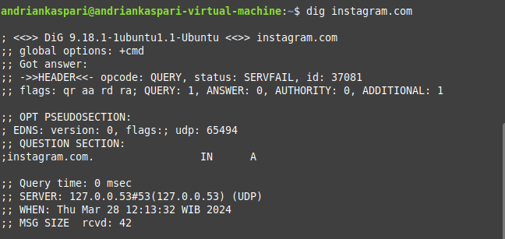

Gmail.com

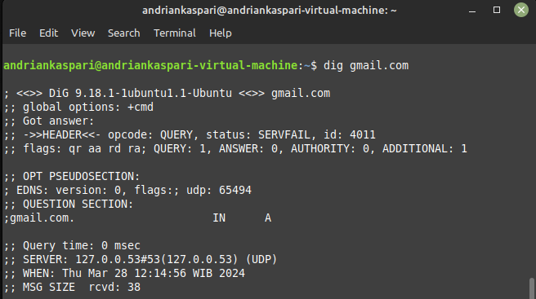

Telegram.com

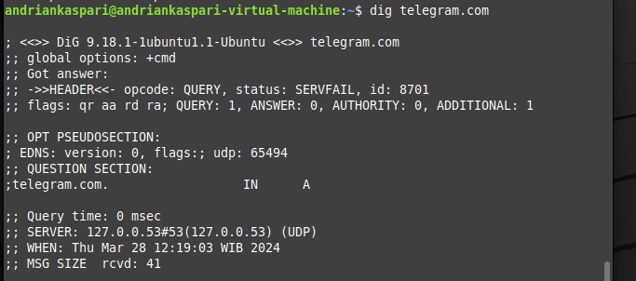

Mikrotik.com

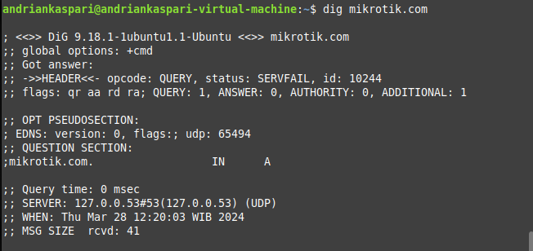

**Nslookup :**

1. Facebook.com

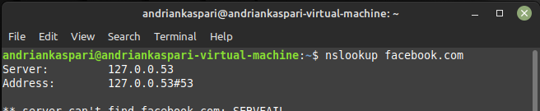

2. Telegram.com

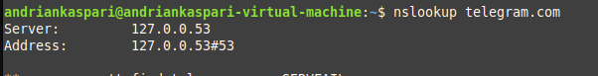

3. Instagram.com



4. Mikrotik.com



5. Google.com

